# Experiment 9: Study of Analog Filters Using Matlab

Aim: This experiment is intended to make the student learn about passive analog filters. Students are expected to write Matlab code, compute and plot the frequency response characteristics of a given filter. Then, by building the filter using R,L& C components, one is expected to measure the gain response of the filter and compare with theoretical estimations.

## Run # 01 : Study of Analog Filter Using RLC components:

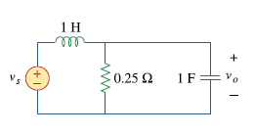

1. Obtain the Transfer Function of the above filter in Laplace Domain.

2. Obtain the poles and Zeros location and draw them in your observation book

2. Plot the Poles and Zeros of this Transfer function in Matlab

NOTE : Explore and learn how to make pole, zero plots in Matlab

3. Obtain the expression for the transfer function in terms of angular frequency

4. Write matlab program to plot magnitude vs angular frequency in normalized units

5. Write matlab program to plot magnitude vs angular frequency in dB units

6. Find the 3 dB cut-off frequency from the plot.

7. What type of filter is this? ( LPF/HPF/BPF/BSF)?

8. Write matlab program to plot phase angle vs angular frequency

## Ans:

R = 0.25;

L = 1;

C = 1;

w = 0:0.1:5;

s = i*w;

sys = R./(s.^2*R*L*C + s*L + R);

sys2 = R./(-w.^2*R*L*C + i*w*L + R);

subplot(411);

plot(w, abs(sys)); grid on;

title("Magnitude in normalised units:");

subplot(412);

plot(w, 20*log10(abs(sys))); grid on;

title("Magnitude in db units:")

% The filter is a low pass filter

subplot(413);

plot(w, angle(sys)); grid on;

title("Phase Angle plot")

sys2 = tf([1], [1 4 1]);

subplot(414);

pzmap(sys2);

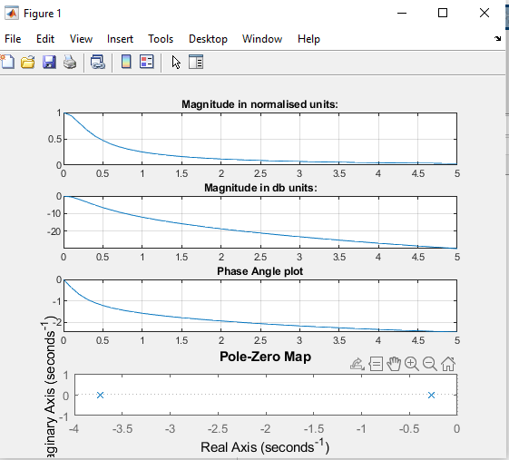

## Run # 02 : Study of Analog Filter Using RLC components:

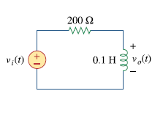

1. Obtain the Transfer Function of the above filter in Laplace Domain.

2. Obtain the poles and Zeros location and draw them in your observation book

2. Plot the Poles and Zeros of this Transfer function in Matlab

NOTE : Explore and learn how to make pole, zero plots in Matlab

3. Obtain the expression for the transfer function in terms of angular frequency

4. Write matlab program to plot magnitude vs angular frequency in normalized units

5. Write matlab program to plot magnitude vs angular frequency in dB units

6. Find the 3 dB cut-off frequency from the plot.

7. What type of filter is this? ( LPF/HPF/BPF/BSF)?

8. Write matlab program to plot phase angle vs angular frequency

Ans:

R = 200;

L = 0.1;

w = 0:0.1:5;

s = i*w;

sys = (L*s)./(s*L + R);

sys1 = (L*w*i)./(w*L*i + R);

subplot(411);

plot(w, abs(sys)); grid on;

title("Magnitude in normalised units:");

subplot(412);

plot(w, 20*log10(abs(sys))); grid on;

title("Magnitude in db units:")

subplot(413);

plot(w, angle(sys)); grid on;

title("Phase Angle plot")

% The filter is a high pass RL filter

sys2 = tf([0.1 0], [0.1 200]);

subplot(414);

pzmap(sys2);

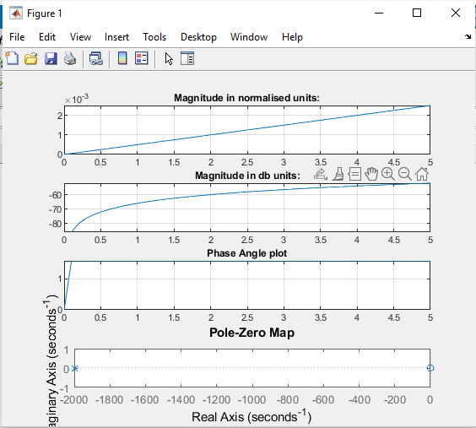

## Run # 03 : Study of Analog Filter Using RLC components:

Consider the RLC circuit given in Figure 1.

Given : L = 100mH, C = 0.01µF and R = 10KΩ

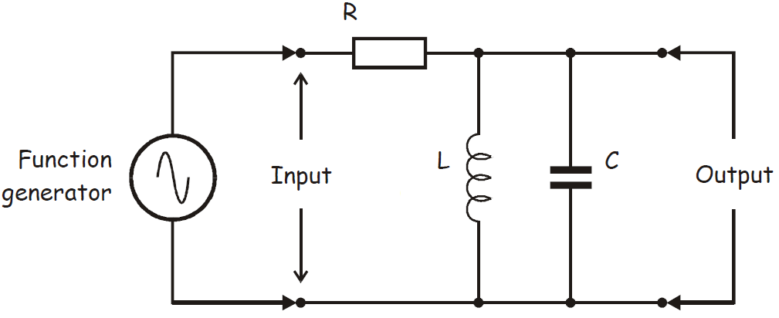

Vout

Vin

1. Obtain the Transfer Function of the above filter in Laplace Domain. Identify the poles

and Zeros location draw them in your observation

2. Plot the Poles and Zeros of this Transfer function in Matlab

NOTE : Explore and learn how to make pole, zero plots in Matlab

3. Obtain the expression for the magnitude square of the transfer function in terms of

frequency “f”

4. Use Matlab and Plot the magnitude square of the transfer function, normalized to

maximum value.

5. Choose the frequency values such that you cover the |H(f)| (normalized) values in the

range of 0 dB to -20 dB. Use semilog scale for the frequency axis and dB for Y-axis..

6. From the frequency response, Note down the 3 dB cut off points. What is the

Bandwidth of this filter?

Ans:

clc

clear

clf

R = 10000;

L = 0.1;

C = 0.01 * 10^-6;

w = 0:0.1:5;

s = i*w;

sys = (L*s)./(s.^2*R*L*C + s*L + R);

sys1 = (L*i*w)./(-w.^2*R*L*C + i*w*L + R);

sys2 = tf([L, 0], [R*L*C, L, R]);

%The expression for the square of the magnitude is:

%(4*pi^2*f^2*L^2)/(R^2*(1 - 4*pi^2*f^2*L*C) + 4*pi^2*f^2*L^2)

%The range of frequencies for 0 to -20 dB ranges from 10^4 to 10^5 rad/sec

bode(sys2);

pzmap(sys2);

bandwidth(sys2)

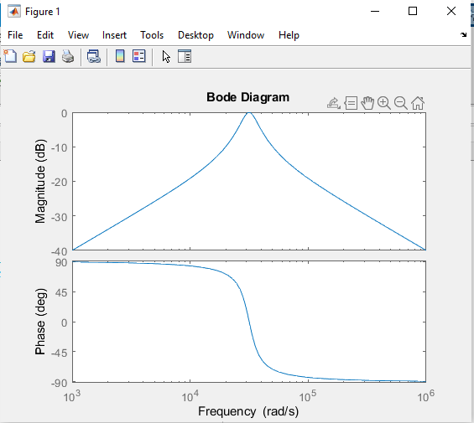

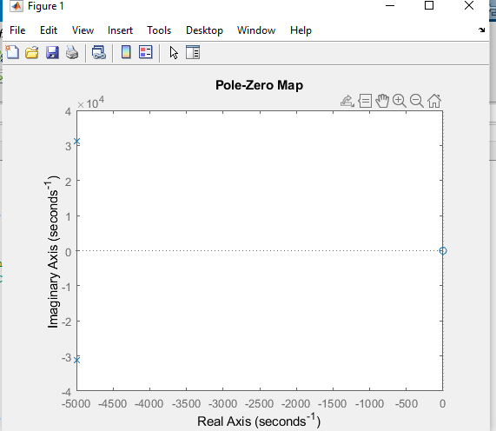

Tuesday Batch file upload link <https://forms.gle/M9uTapeE3qajuGDg8>

Thursday batch file upload link <https://forms.gle/Z2L6WQmGXPdosyox9>

**Additional Problems**

## Run # 04 : Study of Transfer function

The transfer function of a dynamic system is given below

$$H\left(s\right)=\frac{s^{3}-s^{2}+4s+3.5}{2s^{3}+3s^{2}-2.5s+6}$$

1. Plot the Poles and Zeros of this Transfer function in Matlab
2. Derive the expression for the magnitude square of the transfer function in terms of frequency “f” (i.e convert S to jω then to f ).
3. Use Matlab and Plot the magnitude square of the transfer function, normalized to maximum value.

4. Choose the frequency values such that you cover the |H(f)| (normalized). Use semilog scale for the frequency axis and dB for Y-axis..

5. From the frequency response, Note down the 3 dB cut off points. What is the Bandwidth of this filter?

6. What type of filter is this?